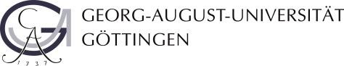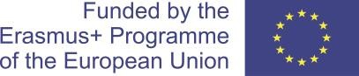

GO INTERNATIONAL PLUS 2020

Call
Within the programme
“Erasmus+ Key Action 107 (Mobility with Partner Countries)”

Student mobility for studies
from the Royal University of Bhutan (RUB); Bhutan

to the Georg-August Universität Göttingen (UGOE), Germany

General overview:

The Georg-August Universität Göttingen (UGOE) offers:

4x MSc in Natural Resources Management student mobility for studies in the field of Forestry, Agriculture or Information & Communication Technology (from CNR,RUB to UGOE) with a duration of 5 months each.

Financial Coverage:

Academic Level | Duration | Travel support | Individual support
MSc. NRM students from CNR, RUB to UGOE | 5 months | 820 EUR | 850 EUR per month

Insurance:
All grant holders are insured by a central Group Insurance, which will be centrally organised by the Project Coordination Team upon successful nomination. The insurance costs (approximately 0,99 EUR per day) are deducted from the individual support.

Please note that there was a change in German legislation related to the residence title for study purposes. In the future, all incoming international students are required to get a German public health insurance. The law affects all mobilities from October 2018 onwards. The German public health insurance costs approx. 90-100 € per month. You will be informed upon your arrival/during the introductory days how to get this insurance.

Tuition fees:
The receiving institution will not ask the grantee to pay fees for tuition, registration, examinations or for access to laboratory and library facilities during his/her mobility period. Nevertheless, the grantee may be charged a fee on the same basis as local students for costs such as student unions and the use of study-related materials or equipment.

Required language skills:
Forestry: English B2, German level B1 recommended

Application:

Please use the below URL for the application:

https://goettingen.moveon4.de/form/5e45241c56c8ff1e2408c8c9/eng

The deadline for submission of the applications is on Thursday, 21st July 2022.

In the framework of this call for applications within the Erasmus+ Programme, persons with disadvantaged backgrounds are strongly encouraged to apply and, in cases of equal qualification, aptitude and expertise, they will be given preferential consideration in selection.

The Erasmus+ Programme promotes equal opportunities and inclusion for all participants regardless of gender, age, sexual orientation, religion or ideology, disability and chronic illness, ethnic and social background. The actions aim at facilitating the access to the participants with disadvantaged groups and special needs. The University of Göttingen and Royal University of Bhutan recognize that faculty, staff, and students need an environment in which they are respected and valued for their contributions in order to work and study effectively. This applies irrespective of their age, (dis)ability, gender, sexual orientation or identity, marriage and civil partnership, pregnancy and maternity, ethnic origin, and religion and belief

